

Class : XIIth Subject : PHYSICS
Date : DPP No. : 4
Topic :- Dual nature of radiation and matter

1. | The figure showing the correct relationship between the stopping potential $V_{0}$ and the frequency $v$ of light for potassium and tungsten is
 | a) | V₀  1.5  1.0  0.5  K  W  0  ν ×10¹⁵  Hz  (eV) | b) | V₀  1.5  1.0  0.5  K  W  0  ν ×10¹⁵  Hz  (eV) | c) | V₀  1.5  1.0  0.5  K  W  0  ν ×10¹⁵  Hz  (eV) | d) | V₀  1.5  1.0  0.5  K  W  0  ν ×10¹⁵  Hz  (eV)
2. | The de-Broglie wavelength of a proton (charge =1.6$×{10}^{-19}$ C, mass=$1.6×{10}^{-27}$ kg)  accelerated through a potential difference of 1kV is
 | a) | $$600 Å$$ | b) | 0.9$×{10}^{-12}$ m | c) | $$7 Å$$ | d) | o.9 nm
3. | The potential difference applied to an $X$-ray tube is $5kV$ and the current through it is $3.2 mA.$ Then the number of electrons striking the target per second is
 | a) | $$2×{10}^{16}$$ | b) | $$5×{10}^{16}$$ | c) | $$1×{10}^{17}$$ | d) | $$4×{10}^{15}$$
4. | Which is not true with respect to the cathode rays
 | a) | A stream of electrons |  |  | b) | Charged particles
 | c) | Move with speed same as that of light |  |  | d) | Can be deflected by magnetic fields
5. | If in a photoelectric experiment, the wavelength of incident radiation is reduced from $6000 Å$ to $4000 Å$ then
 | a) | Stopping potential will decrease |  |  | b) | Stopping potential will increase
 | c) | Kinetic energy of emitted electrons will decrease |  |  | d) | The value of work function will decrease
6. | Photon of frequency v has a momentum associated with it. If c is the velocity of light, the momentum is
 | a) | v/c | b) | hvc | c) | $$hv/c^{2}$$ | d) | $$hv/c$$
7. | Air becomes conducting when the pressure ranges between
 | a) | 76 cm and 10 cm | b) | 10 cm and 1 cm | c) | 1 cm and ${10}^{-3}$ cm | d) | ${10}^{-4}$cm and ${10}^{-7}$cm
8. | The specific charge of a proton is $9.6×{10}^{7} {Ckg}^{-1}.$The specific charge of an alpha particle will be
 | a) | $$9.6×{10}^{7} {Ckg}^{-1}$$ | b) | $$19.2×{10}^{7} {Ckg}^{-1}$$ | c) | $$4.8×{10}^{7} {Ckg}^{-1}$$ | d) | $$2.4×{10}^{7} {Ckg}^{-1}$$
9. | What should be the velocity of an electron so that its momentum becomes equal to that of a photon of wavelength 5200$Å$ ?
 | a) | $${10}^{3}ms^{-1}$$ | b) | $$1.2×{10}^{3}ms^{-1}$$ | c) | $$1.4×{10}^{3}ms^{-1}$$ | d) | $$2.8×{10}^{3}ms^{-1}$$
10. | In a photoelectric experiment the relation between applied potential difference between cathode and anode V and the photoelectric current I was found to be shown in graph below. If Planck’s constant $h=6.6×{10}^{-34}Js$, the frequency of incident radiation would be nearly $(in s^{-1})$  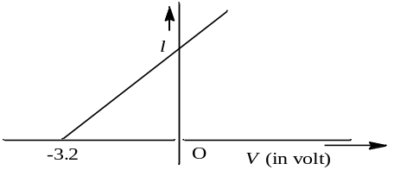
 | a) | $$0.436×{10}^{18}$$ | b) | $$0.436×{10}^{17}$$ | c) | $$0.775×{10}^{15}$$ | d) | $$0.775×{10}^{16}$$
11. | The anode voltage of a photocell is kept fixed. The wavelength $λ$ of the light falling on the cathode is gradually changed. The plate current 1 of the photocell varies as follows
 | a) | 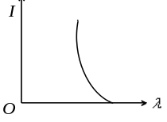 | b) | 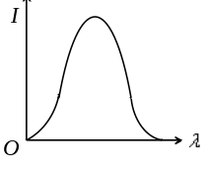 | c) | 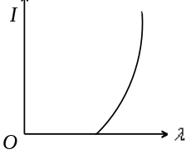 | d) | 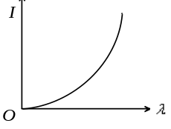
12. | If an electron and proton are propagating in the form of waves having the same wavelength, it implies that they have the same
 | a) | Energy | b) | Momentum | c) | Velocity | d) | Angular momentum
13. | The correct curve between the stopping potential $(V)$ and intensity of incident light $(I)$ is
 | a) | V_{o}  I | b) | V_{o}  I | c) | V_{o}  I | d) | V_{o}  I
14. | While doing his experiment, Millikan one day observed the following charges on a single drop  (i)$6.563×{10}^{-19}C$ (ii)$8.204×{10}^{-19}C$  (iii)$11.50 ×{10}^{-19}C$ (iv)$13.13×{10}^{-19}C$  (v)$16.48×{10}^{-19}C$ (vi)$18.09×{10}^{-19}C$  From this data the value of the elementary charge $(e)$ was found to be
 | a) | $$1.641×{10}^{-19}C$$ | b) | $$1.630×{10}^{-19}C$$ | c) | $$1.648×{10}^{-19}C$$ | d) | $$1.602×{10}^{-19}C$$
15. | Which of the following shows particle nature of light
 | a) | Refraction | b) | Interference | c) | Polarization | d) | Photoelectric effect
16. | When an inert gas is filled in place of vacuum in a photo cell, then
 | a) | Photo-electric current is decreased
 | b) | Photo-electric current is increased
 | c) | Photo-electric current remains the same
 | d) | Decrease or increase in photo-electric current does not depend upon the gas filled
17. | Momentum of a photon of wavelength $λ$ is
 | a) | $$h/λ$$ | b) | $$hλ/c^{2}$$ | c) | $$h λ/c$$ | d) | Zero
18. | Molybdenum is used as a target element for production of X-rays because it is
 | a) | A heavy element and can easily absorb high velocity electrons
 | b) | A heavy element with a high melting point
 | c) | An element having high thermal conductivity
 | d) | Heavy and can easily deflect electrons
19. | In Millikan’s oil drop experiment, an oil drop of mass $16×{10}^{-6}$ kg is balanced by an electric field of ${10}^{6} {Vm}^{-1}$. The charge in coulomb on the drop is  $$(assuming g=10 {ms}^{-2})$$
 | a) | 6.2$×{10}^{-11}$ | b) | 16$×{10}^{-9}$ | c) | $$16×{10}^{-11}$$ | d) | $$16×{10}^{-13}$$
20. | The $X$-ray beam coming from an $X$-ray tube will be
 | a) | Monochromatic
 | b) | Having all wavelengths smaller than a certain maximum wavelength
 | c) | Having all wavelengths larger than a certain minimum wavelength
 | d) | Having all wavelengths lying between a minimum and a maximum wavelength

